

School of Computing, Creative Technology and Engineering

**Module: Fundamentals of Computer Programming**

**Academic Year: 2023/24**

**Level 4: Semester 1**

**Assignment Title: Week 5**

**Date Due: January 16, 2025**

**Tutor: Saurav Gautam**

**Student Name: Sange Doma Tamang**

**Student ID: 10260**

GitHub link: <https://github.com/Sangedoma/Programming-Portfolio/tree/main/portfolio>

**Building a Programming Portfolio**

**Week-5**

1. Using command-line arguments involves the sys module. Review the docs for this module and using the information in there write a short program that when run from the command-line reports what operating system platform is being used.

**Code:**

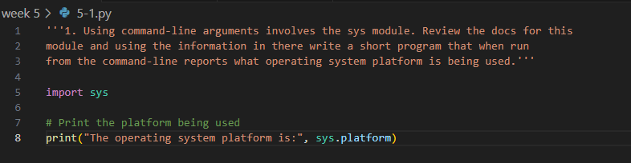

**Output:**

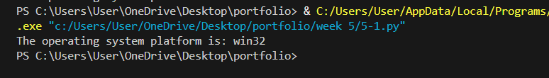

1. Write a program that takes a bunch of command-line arguments, and then prints out the shortest. If there is more than one of the shortest length, any will do. Hint: Don't overthink this. A good way to find the shortest is just to sort them.

**Code:**

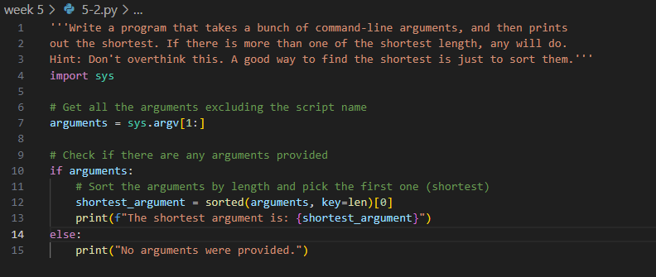

**Output:**

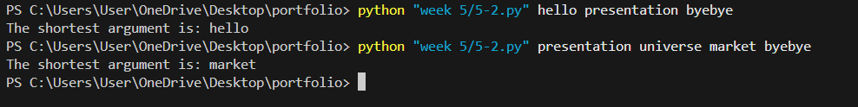

1. Last week you wrote a program that processed a collection of temperature readings entered by the user and displayed the maximum, minimum, and mean. Create a version of that program that takes the values from the command-line instead. Be sure to handle the case where no arguments are provided!

**Code:**

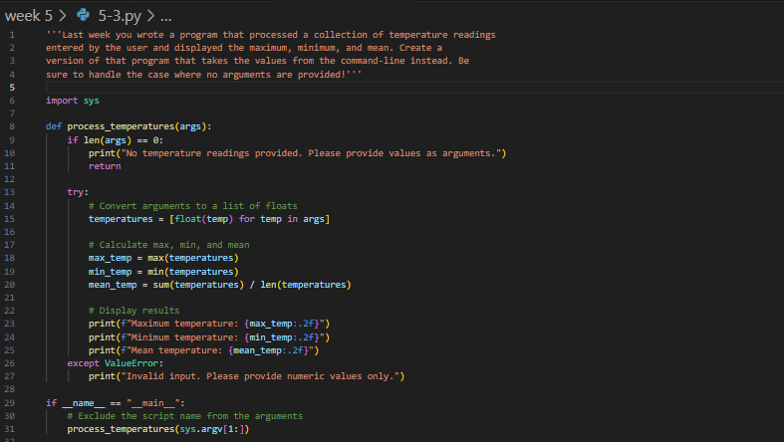

**Output:**

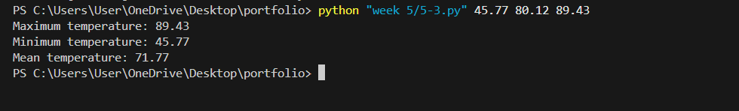

1. Write a program that, when run from the command line, reports how many arguments were provided. (Remember that the program name itself is not an argument).

**Code:**

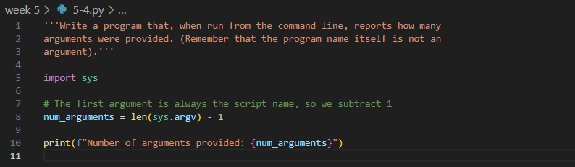

**Output:**

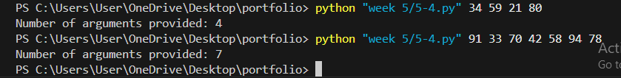

1. Write a program that takes the name of a file as a command-line argument, and creates a backup copy of that file. The backup should contain an exact copy of the contents of the original and should, obviously, have a different name.

**Code:**

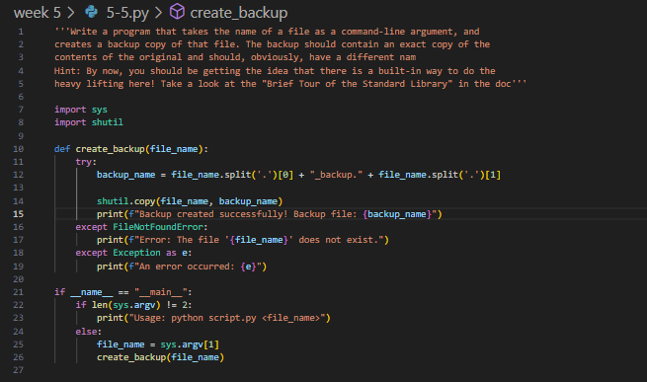

**Output:**

